**Document Title**

**Main Section**

Subtitle (or descriptor)

**Date:** 9/21/16

**Revision:**

**Author:** Justin Reina

**Organization:** (or company)

**Field 1:** description

**Field 2:** …

**Field 3:** …

**Summary:**

When a summary is present it is listed here

**Notice:**

This document is not a requirement, rather a strong suggestion. In this it is also expected to change over time

(page left blank)

**Table of Contents**

1 Document Structure 4

2 Document Formatting 5

3 Document Label and Numbering 5

3.1 Numbering Schema Example 5

4 Document Storage and Sharing 6

4.1 Revision Control 6

4.2 Revision Numbering 6

4.3 Document Fields 7

5 Access Levels 7

6 Notation 8

7 References 8

7.1 Reference Type A 8

7.2 Additional References 8

# Document Structure

All content listed here is subject to change, given advanced notice but is not expected to at this time.

* 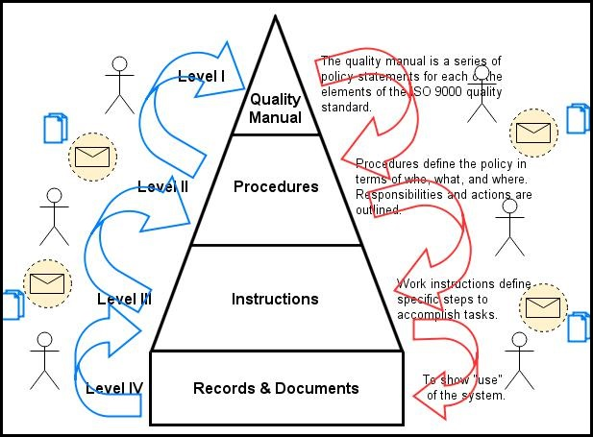Page 1 – Title Page
  + Title page in equivalence to the one used here, including fonts and spacing
* Page 2 – Blank
  + Left blank with a centered notice
* Page 3 – Table of Contents
  + Table of Contents in equivalence to the one used here
* Page 4+ – Content
  + The first page of content after the ToC always begins on an odd numbered page, to present the page face forward
  + There is an ‘About This Document’ section here if needed or desired. This template

**Figure 1**: An example of a caption for this picture

document omits this as it does not need this

* + There is a ‘References’ section here if needed or desired next. See Section X following for example illustration of this

The following table is an illustration of a table which may be inserted into a document to provide description and text.

**Table 1**: Terms, Abbreviations and Acronyms

|  |  |
| --- | --- |
| Term | Description |
| ABS | Type of polymer plastic |
| Activated | The state of a tag after activation at the licensing authority |
| AES | Advanced-Encryption Standard. Block Encryption Algorithm. |
| AVI | Automatic Vehicle Identification |
| CSPRNG | Cryptographically-Secure Pseudo-Random Number Generator. |
| EPC | Electronic Product code. |
| FLASH | A non-volatile form of memory |
| FOV | Field-of-View |
| Initialization State | The state of a product after manufacture but before activation. |
| RF | Radio-Frequency |
| Release #X | Indicates a product release |
| RFID | Radio frequency identification |
| RN16 | A random number of 16 bits |
| RNG | Random Number Generator. Functionally, a module which outputs random numbers generated from an entropy source |

# Document Formatting

* Margins are narrow, 0.5” around
* The Footer is present, with a unique configuration for the first page
  + First Page: No footer
  + Else: Confidentiality Notice (Date), Page Number, Revision
  + e.g. ‘ *XYZ Confidential. September 2016’, ‘Page 1 of 12’, ‘Revision 1.1’*
* There is no corporate logo at this time, but may be included at a later date
* When full size pictures are used they contain a small black border (e.g. a cell phone picture)
* Document Fonts and spacing are to match this document
* Hyperlinks are emphasized when references are needed or of value, either to [web links](https://techcrunch.com/), [emails](mailto:justinmreina@gmail.com?subject=Example%20Subject) or drive locations

# Document Label and Numbering

* All pictures, figures and tables include a Caption (e.g. *Figure 1: Some Product Diagram*)
* Starting at Page 3 on the Table of Contents each page has a header indicating the active section
* Sections are numbered as found in this document, using the same schema and formatting

## Numbering Schema Example

This section simply illustrates a sub heading

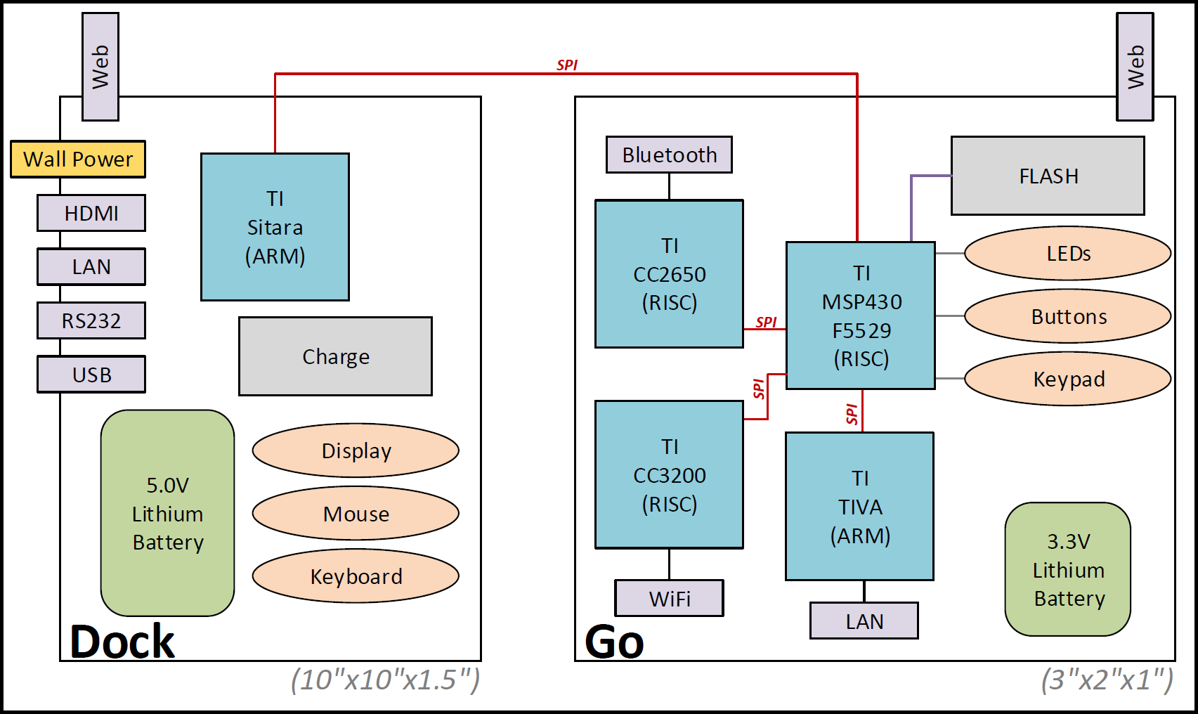

**Figure 2**: An example of a caption for this diagram

# Document Storage and Sharing

Documents are identified quite simply for one of two means of storage or distribution –

* Communication
  + Document is transmitted as a set, deliverable (PDF) and generation docs (DOCX, XLSX, etc.). All generation docs are stored in a Suppl.zip
  + Revision numbers and dates are strongly suggested and softly required for all documentation communicated. This can be informal (e.g. an ‘r1’ in the doc corner) or formal (e.g. doc footer with ‘Revision 1.0’)
* Storage
  + Preferred to use the communication methodology, as the default usage
  + Source Code Control (git) is used and strongly recommended at all times
    - Even for DOCX, etc.!
    - Consider spanning the git on the entire directory, when needed. E.G. git source code control over the directory and work of ‘customerDemo_apple-feb/’, over all files inside of it
    - Tags and Branches are strongly emphasized here!! ☺
  + Directories are established alongside the document, Suppl/ and Archived/
  + All file revisions are archived in Archived, with revision number inserted into the document name e.g. *documentName_r1_1.PDF, Suppl_r1_1.zip, documentName_r1_1.docx*

## Revision Control

Revision Control is strongly recommended and softly enforced for all documents, even including this one (see .git/ in same directory as this file. Git is recommended for use at all times, for simplicity and maximization of portability and review.

## Revision Numbering

For content to have persistent value, meaning and have placement into the larger context of the work it contributes to revision control and date identification is a pre-requisite. Contact Justin with questions. In this it is a requirement for all engineering work in firmware and software documentation, and strongly emphasized for all other forms (e.g. that casing design or PCB design) of documentation, be it Word, PowerPoint, Excel, etc.

From this an importance in unified and clear communication and usage of revisioning is identified, and presented here. All documents are maintained with revision identification identified in at least one location on the document

**Revision Numbering Formats**

* Simplest
  + (no rev) for ‘no revision’
* Basic
  + (r1) Somewhere, anywhere that the user is able to find
  + (rev1) is also an option if desired
* Standard
  + (Revision 1.0) Right corner of footer
* Official
  + Standard form plus on Title Page (like in this document)

Additionally, a ‘Revision History’ section is encouraged in any long-standing documents, to capture changes and document flow. This can either be internal to the document or external (either on a document or webpage)

## Document Fields

Updateable document fields are strongly recommended for use, at all times if possible. The simplest and most important example is of the document revision number, and is listed here for example. This full methodology shown below is also used in this document, inspect the source .docx for review.

* Create a new Property Field (File->Info->Advanced Properties [under 'Properties'])
  + Custom Tab
  + Name: "*Example Field*"
  + Type: Text
  + Value: "1.0"
  + Click 'Add', then 'OK'
    - This adds it to the displayed 'Properties' listing
    - If you ever want to revise or change it, come back to this listing and select it, update the displayed value in 'Value' and press the new 'Modify' button
* Insert the new field into use in document
  + From document you want to insert this into (Insert->Text->Quick Parts->Field)
    - Category: Document Information
    - Field name: DocProperty
    - Property: '*Example Field*'
* Whenever update of the value is needed use the process listed above to re-access the property. Then press Ctrl+A, then F9 and select ‘All’ for update to complete. This does not apply to Headers & Footers, these need manual updates (R.C.->Update Field), not sure why but quite easy to do!

# Access Levels

The following levels will be used for listings of Confidentiality Notice

* <unlisted>
  + no access level or confidentiality notice
* Official
  + ownership of document identified with public access permitted
* Listed Parties Confidential
  + e.g. Jim, Bob & Sally Confidential

# Notation and Tags

Short acronyms contained within parenthesis are encouraged for use in tagging and notation within living notes (not within standard documentation or publications, like this doc). Common uses are listed below, and can be extended or adapted at will by any author.

* (G) - Goal
* (T) – Target
* (in prog) – Section or item in progress
  + When used this typically is non-permanent and will be removed on completion of identified task
* (min)/(max)/(typ) – Qualification of metric
* (M) - Maybe
* (L) - Likely
* (P) – Probable / Probably
* (R) – Risk

Such acronyms will also be appended in standard documents periodically, performed with the following syntax –

* CostG, Currentmax, DurationT, velocitymax,
* speed: 5/10/20 [mphmin/targ/max­]

The following conventions and syntaxes are applied to tagging notation

* Use of parenthesis - e.g. (rev1)
  + Standard engineering tag notation
* Use of carrot brackets - e.g. <in prog>
  + Temporary tag which is intended for eventual removal
* Use of apostrophes - e.g. ‘Yet to be Tested’
  + Customer or external communications, e.g. in a sales pamphlet for supplementary description or context

# References

A short description is given illustrating this sections seed, intent, customer and value. The sources for all references is strongly and clearly illustrated here

## Reference Type A

Here is a Type A description or qualification:

[A] This is reference 4.1.A, and a hyperlink and context may be provided here, including titles, dates & authors

[B] This is reference 4.1.B

[C] This is reference 4.1.C

## Additional References

[A] This is reference 4.2.A, and a hyperlink and context may be provided here, including titles, dates & authors

[B] This is reference 4.2.B

[C] This is reference 4.2.C